11.
Create GPG key pair.
# gpg --full-generate-key
- Enter the key-size you want (I have entered 4096 for a strong key)
- Specify the validity period for the key.
- Enter identity field information as below.
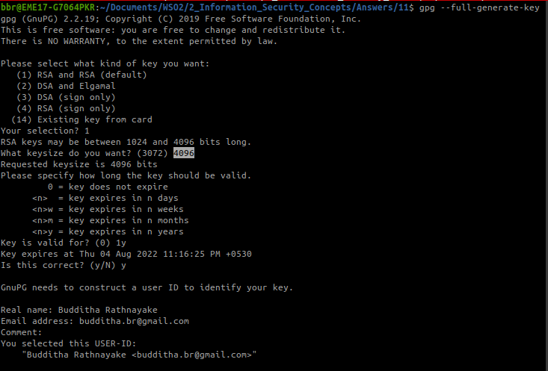
- Enter a passphrase to protect the key in prompted window.
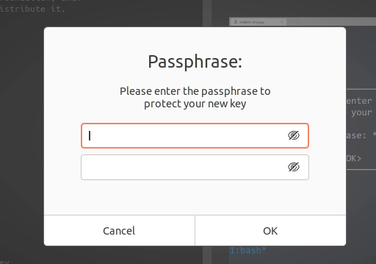

- After some time, public key and secret key is created.
- It is mentioned the expired date and details of the key.
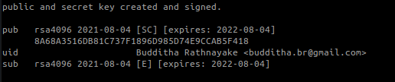
Export the created public key in order to upload to keys.openpgp.org
# gpg --export --armor --output budditha.gpg.pub budditha.br@gmail.com
Then upload it to the keys.openpgp.org and verify the email sent to your email address.
That's it . public key is uploaded to public key-server.
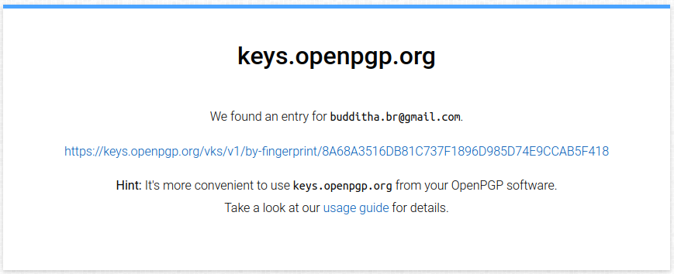
URL to the key : https://keys.openpgp.org/vks/v1/by-fingerprint/8A68A3516DB81C737F1896D985D74E9CCAB5F418

